BRAC UNIVERSITY

**Department of Computer Science and Engineering**

CSE422: Artificial Intelligence

**Question 1**

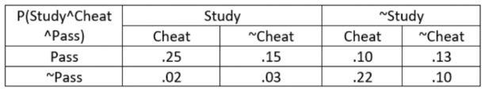

a) Compute whether cheat and pass conditionally independent given study. Show all calculations.

b) Compute P(Pass or Cheat).

**Question 2**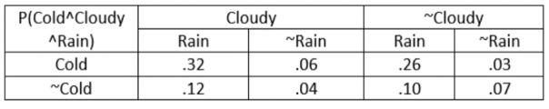

a) Compute the marginal probability of ~Cold.

b) Compute the probability of not cloudy given the it is not raining and the weather being not cold

c) Compute the probability of not raining given it is not cloudy.

d) Compute P(~Rain or cloudy)

**Question 3**

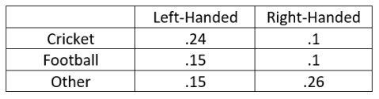

a) Compute the probability of playing football for a left-handed person

b) If someone plays Cricket, estimate the probability of being right-handed

c) Compute the probability of playing Football and Cricket

d) Compute the probability of being right-handed or left-handed

e) Infer whether playing football depends on being Right-Handed

**Question 4**

A patient went to the hospital and diagnosed Covid Positive. The doctors informed him that their test can successfully detect Covid positive 92% of the time and can not detect Covid negative 4% of the time. If stats say that around 7% people are covid affected globally, what is the marginal probability of being detected covid positive?

**Question 5**

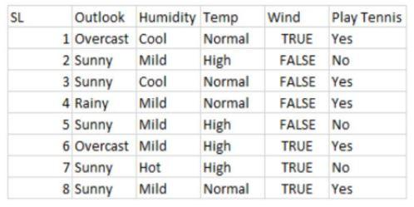

1. Is a player going to play tennis given the outlook is Sunny, humidity is Mild, temperature is Normal, and the weather is windy? Apply Naive Bayes and show proper calculations with the learning phase.
2. Is the player going to play tennis if the outlook is overcast, humidity is hot instead? Show full calculation.

**Question 6**

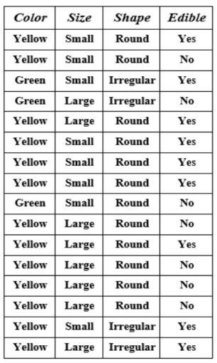

1. Considering ‘Edible’ as the class, Compute entropy for this dataset.
2. Between Color, Size, and Shape, which one is the better feature? Show full calculation and explain.

**Question 7**

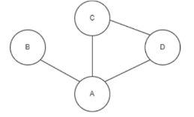

Consider the constraint graph of a problem above, where each region has to be filled up with either 1, 2, or 3. No two adjacent regions can have the same digit.

a. Formulate the variable, domain, constraint, and the goal of the problem.

b. Based on the variable ordering procedure, mention the order of variables to be assigned with digit. Provide adequate explanation for your ordering.

c. Consider that node B already has digit 1 and all the other nodes are empty. If you are to provide digit to node D next, which digit should you pick? Identify your choice based on value selection procedure.

d. If node B has digit 1, node D has digit 2, and rest of the nodes are unassigned, does the constraint graph remain arc consistent? Why or why not? Explain.